 | Sri Balaji University, Pune  School of Computer Studies | 

PROJECT REPORT ON
“Telco Customer Churn Analysis”

A Project submitted to
Sri Balaji University for partial completion of the degree of
Master of Computer Application

By:
Sharwari Hanumant Ghadge
MCA2302190

Under the guidance of
Prof. Punam Nikam

April 2025

Sri Balaji University, Pune

School of Computer Studies

CERTIFICATE
This is to certify that Sharwari Hanumant Ghadge, a student of Master of Computer Applications (MCA) Batch 2023-25 at Sri Balaji University Pune, has successfully/partially completed their internship project titled “Telco Customer Churn Analysis” at TRON Softech Pvt.Ltd as a part of the curriculum requirements.
The internship was carried out from 1st October to 1st April, during which the student demonstrated a keen interest in learning, professionalism, and dedication towards the assigned tasks.
This certificate is issued as a recognition of the successful completion of the internship and submission of the internship project report as per the university guidelines.
Date: 1/04/2025
Place: Pune

Signature of Faculty Guide  Prof. Punam Nikam  Assisstant Professor  School of Computer Studies  Sri Balaji Univeristy Pune | Signature of Head of Department  Dr. Richa Purohit  Vice Principal  Sri Balaji University Pune


TRONSOFTECH

TRONSOFTECH PVT LTD, Kesnand Rd, near TVS Showroom, Kesnand, Wagholi, Pune, Maharashtra 412207 |
Email:info@tronsoftech.in | Phone:8087611678

Date: 12th September, 20 21
Letter of Employment
Dear Ms. Sharwari Hanumant Ghadge,

Sub: Appointment as Data Analyst at TRONSOFTECH.
We refer to the discussion regarding the above and are pleased to appoint you as Data Analyst on contractual employment on the following terms:
- Your tenure as Data Analyst at TRONSOFTECH shall be from 1st October, 2024.
- You are presently required to work on 1st October, 2024 at (TRONSOFTECH PVT LTD, Kesnand Rd, near TVS Showroom, Kesnand, Wagholi, Pune, Maharashtra 412207).
- You will be paid a consolidated salary of Rs. 5000 per month (Rs. 60000 Per Annum).
- This permanent employment can be terminated by either party by giving two month notice period, in writing, or by payment of two month salaries in lieu of the notice period.
- Your leave entitlements shall be based on the Company’s leave policy applicable to permanent employees from time to time.
- During your tenure with the Company you may be mobilised or delegated to any of the offices/ projects/ divisions/ unit/ departments of the Company, existing or to be set up at any other location, without any additional remuneration.
- You will pay all your tax liabilities including income tax and any other charges as maybe applicable on the above salary and the Company shall not be liable for the same. The Company shall deduct taxes as applicable (if any) under the Income Tax Act, 1961 and professional tax pertaining to the payment of salary.
- Kindly note that the position offered is a permanent position and will not be at par with the position of regular full time employee of the Company.
- During the tenure of your assignment with the Company, you shall maintain utmost confidentiality in all respects of your work. Similarly, you shall not disclose any information to any third party other than as required for rendering services under this permanent employment.
- In the event of breach any of the terms of your employment agreement, the Company shall be entitled to initiate appropriate action including immediate termination of your employment without notice and initiating appropriate civil and criminal action.
- During the tenure of your employment, you shall defend, indemnify and hold the Company harmless from any/ all claims, liabilities, losses, costs arising from or in connection with any negligent, intentional act or omission on your part.
- You will abide by all the rules and regulations of the Company which are in force from time to time.


Thanking you,
Director - Mr. Sushant Gore
TRONSOFTECH

STUDENT DECLARATION
Sri Balaji University Pune
Master of Computer Applications (MCA)

Declaration
I, Sharwari Hanumant Ghadge, a student of Master of Computer Applications (MCA) at Sri Balaji University Pune, hereby declare that the internship project report titled:
“Telco Customer Churn Analysis”
submitted in partial fulfillment of the requirements for the degree of Master of Computer Applications (MCA) is my original work. The project was carried out at TRON Softech Pvt.Ltd, under the guidance of Omkar Gunjal, and it has not been submitted in full or part for any other degree or diploma at any university or institution.
I also affirm that all the data, information, and content presented in this report have been obtained and presented following academic and ethical principles. Any references or borrowed content have been duly acknowledged.
I understand that any plagiarism or academic dishonesty, if found at any stage, may lead to the rejection of this report.


Student Name: Sharwari Hanumant Ghadge
Enrollment Number: MCA2302190
Batch: 2023-25
University/Institute Name: Sri Balaji University Pune
Date: 31/03/2025
Signature:

ACKNOWLEDGEMENT
I would like to express my sincere gratitude to everyone who contributed to the successful completion of my internship project, Telco Customer Churn Analysis, as a part of my Master of Computer Applications (MCA) program at Sri Balaji University Pune.
First and foremost, I extend my heartfelt thanks to TRON Softech Pvt.Ltd for providing me with this valuable opportunity to undertake my internship and gain practical exposure to the industry.
I am deeply grateful to my industry mentor, Omkar Gunjal, Cloud Engineer for their invaluable guidance, support, and encouragement throughout the internship. Their expertise and insights have helped me gain a deeper understanding of the subject matter.
I would also like to express my sincere appreciation to my faculty guide, Prof. Punam Nikam, from School of Computer Studies, Sri Balaji University Pune, for their continuous support, constructive feedback, and encouragement throughout the project.
I heartily grateful to Prof. Dr. G. Y. Shitole, Principal School of Computer studies and Dr. Richa Purohit, Vice Principal, School of Computer Studies, Sri Balaji University, Pune for their continuous support and guidance.
My special thanks to my colleagues and teammates at TRON Softech Pvt. Ltd for their cooperation, support, and the collaborative learning environment that enriched my experience.
Finally, I am grateful to my family and friends for their constant motivation and encouragement throughout my academic journey.
This internship has been a great learning experience, and I am confident that the knowledge and skills acquired will be invaluable in my future professional endeavors.
Student Name: Sharwari Hanumant Ghadge
Enrollment Number: MCA2302190
Batch: 2023-25
University/Institute Name: Sri Balaji University Pune
Date: 29/03/2025
INDEX
Sr. No. | TITLE | Pg. No
1 | Company Introduction | 8 - 9
 | 1.1 Introduction of Company
 | 1.2 Organization Business Sector
 | 1.3 Organizational Structure
2 | Company Profile | 10 - 11
 | 2.1 Departments of the Company
 | 2.2 Services/Products Offered
 | 2.3 Audit Reports
3 | Conceptual Framework | 12 - 21
 | 3.1 Objective of Study
 | 3.2 Job Description
 | 3.3 Overview of Various Processes
4 | Practical Implementation and Research | 22 - 24
 | 4.1 Work Description within the Organization
 | 4.2 Description of Study/Research Under Supervision
5 | Learning, Conclusions, and Recommendations | 25 - 26
 | 5.1 Behavioral Learning from Organization
 | 5.2 Suggestions and Recommendations
 | 5.3 Project Limitations
 | 5.4 Conclusion

CHAPTER 1
Company Introduction

1.1 Introduction of Company
TRON Softech Private Limited was established in 2012, aiming to provide innovative software solutions to clients across various industries. Over the years, the company has grown to become a trusted name in the field of software development, offering services across the globe.

Mission: Simplify technology solutions.

Vision: Achieve exponential growth and excellence by helping our customers reach their business goals using reliable, innovative and convenient technology solutions.
1.2 Organization Business Sector
TRON Softech operates within the Information Technology and Software Development sector, providing end-to-end software solutions, including web development, mobile app development, cloud computing, and AI-driven services.
1.3 Organizational Structure
The company follows a flat organizational structure, fostering collaboration across teams. The leadership includes the CEO, CTO, and heads of various departments such as software development, sales, and human resources.

CHAPTER 2
Company Profile

2.1 Departments of the Company
TRON Softech is organized into several key departments:
- Software Development: Responsible for coding, testing, and deployment of software applications.
- Research & Development (R&D): Focuses on innovative solutions and emerging technologies.
- Sales and Marketing: Manages client acquisition, partnerships, and market strategies.
- Human Resources: Handles recruitment, employee welfare, and training.
2.2 Services/Products Offered
- Custom Software Development: Building tailored software solutions for clients.
- Mobile App Development: Developing applications for Android and iOS platforms.
- Cloud Solutions: Offering cloud-based services for data storage and computing.
- AI and Machine Learning Solutions: Providing AI-driven software products for business automation.
- Real-time Project-based Courses: Practical, hands-on learning programs in software development, web development, mobile app development, data science, and more.
2.3 Audit Reports
The company undergoes regular financial and operational audits to ensure compliance with industry standards and best practices. The latest audit report confirmed TRON Softech's sTRONg financial position and robust internal controls.

CHAPTER 3
Conceptual Framework

3.1 Objective of Study
The objective of this study is to analyze customer churn in the telecommunications industry. By understanding the key factors that influence churn, the goal is to build predictive models to identify customers who are likely to churn and recommend strategies for retaining them.
3.2 Job Description
Role: Data Analyst Intern
An Associate Data Analyst tasks in this project include data analysis, preprocessing, and building machine learning model. Various machine learning techniques, including logistic regression, decision trees, knn and support vector classifier, are employed to predict customer churn based on historical data.
3.3 Overview of Various Processes
Data Pre processing
EDA
Data Collection

Feature Engineering
One-Hot Encoding
Outlier Analysis

Churn Prediction
Model Evaluation
Model Building

- Data Collection: The dataset used in this analysis contains customer information such as demographics, account information, and service usage. The dataset was loaded using Pandas for analysis and manipulation.
- Data Preprocessing: The raw data was cleaned to handle missing values, inconsistent entries, and categorical variables. Techniques like label encoding were applied to convert categorical data into a numerical format, making it suitable for model training.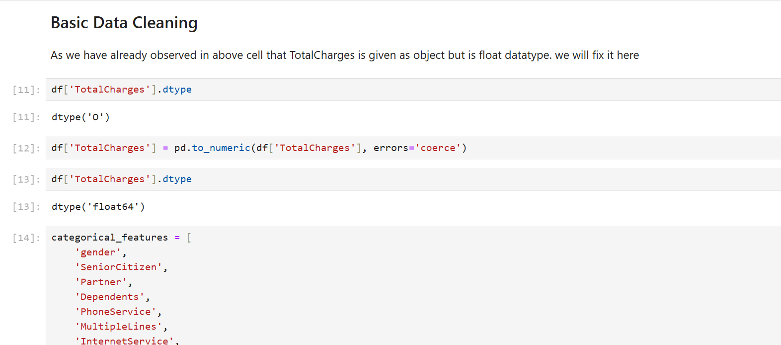
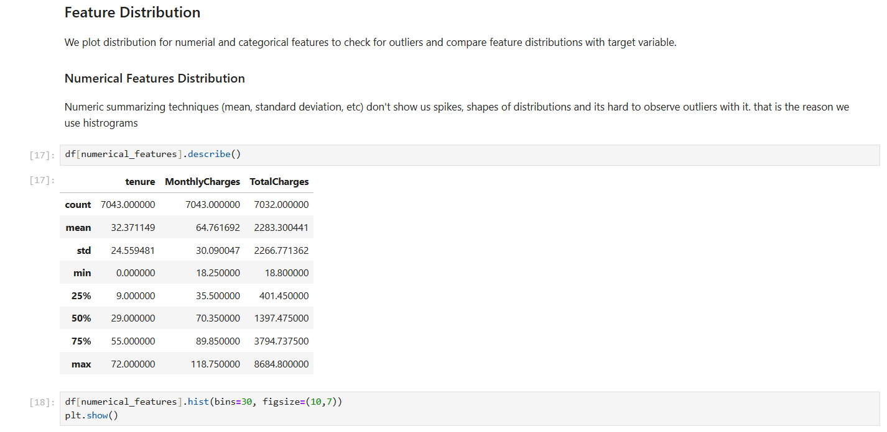
- Exploratory Data Analysis (EDA): Various visualizations were created using Seaborn and Matplotlib to identify relationships between features such as tenure, monthly charges, and churn rate. Correlation matrices were used to understand feature importance.
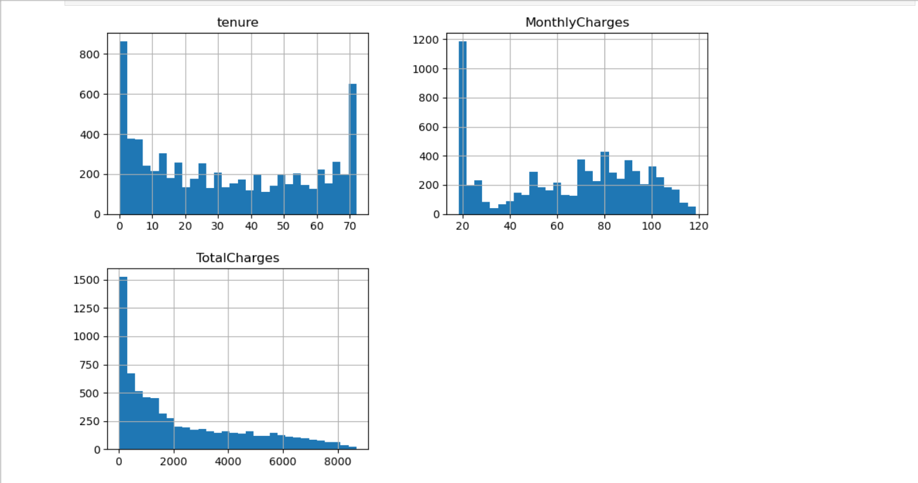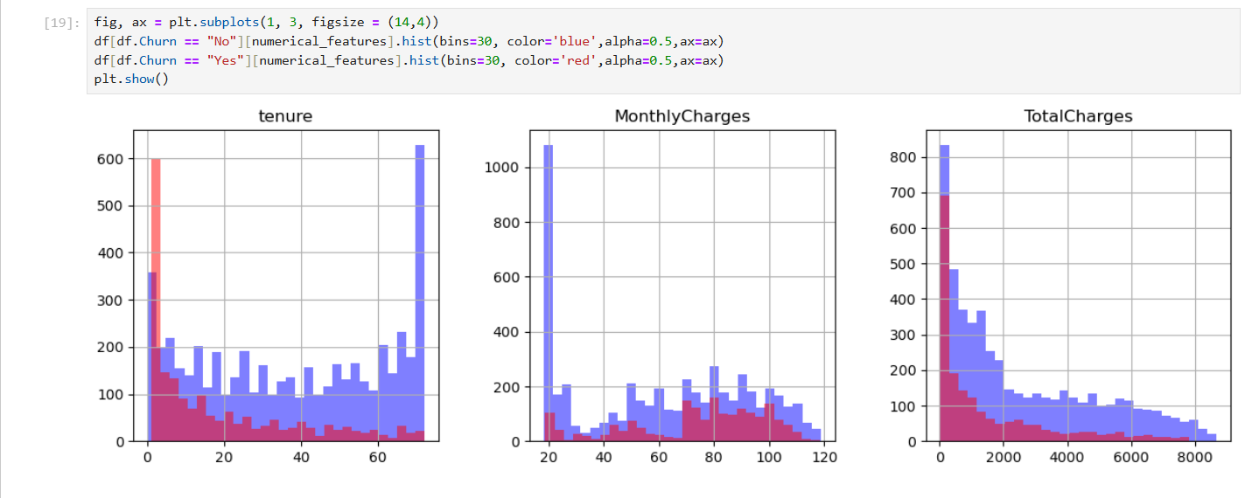
- Outlier Analysis with IQR Method: To find any outliers in the dataset.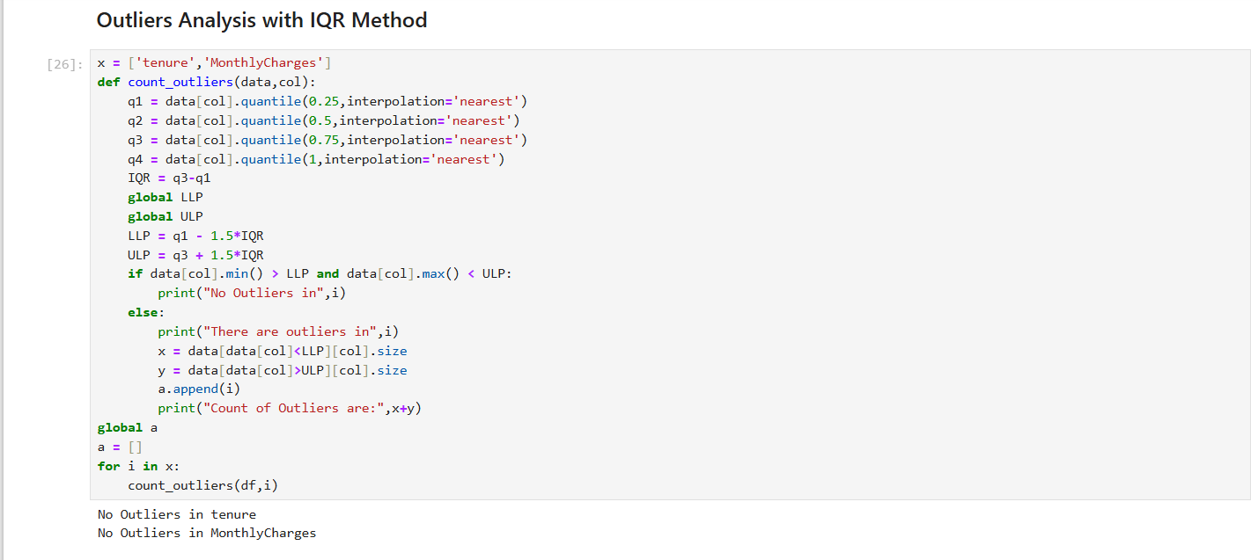
- One-Hot Encoding: To convert categorical features like gender, churn into numerical variables.
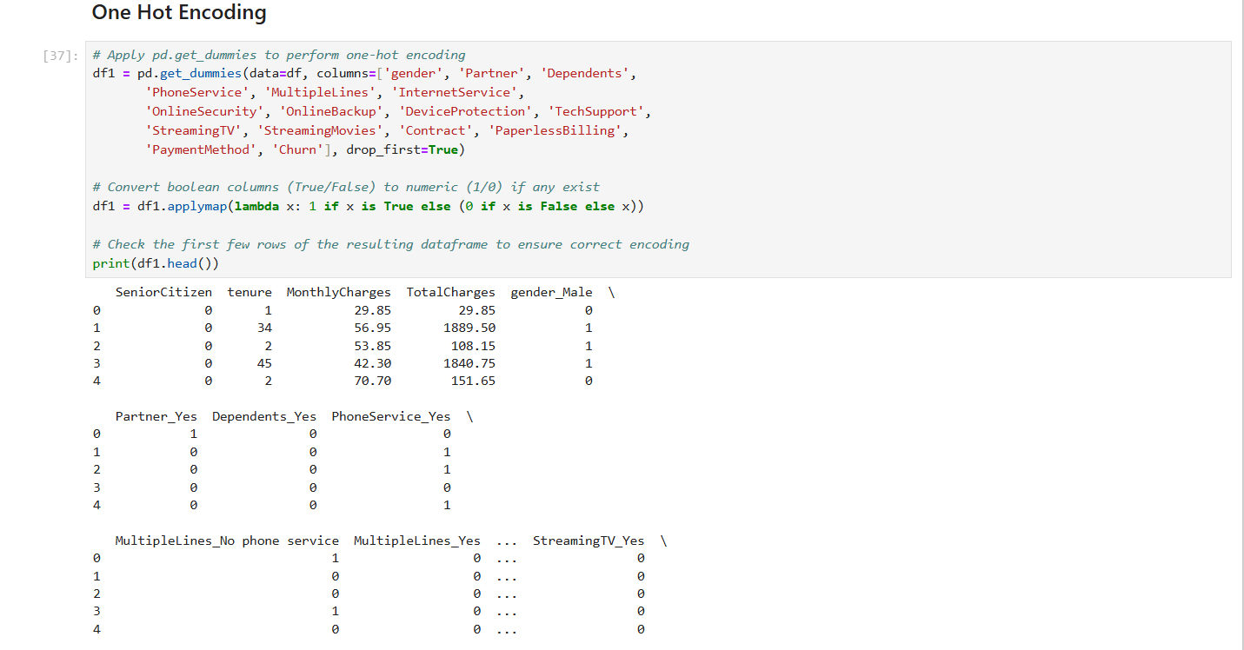
- Feature Engineering: New features were derived to improve the predictive power of the models, such as contract type, payment method, and tenure.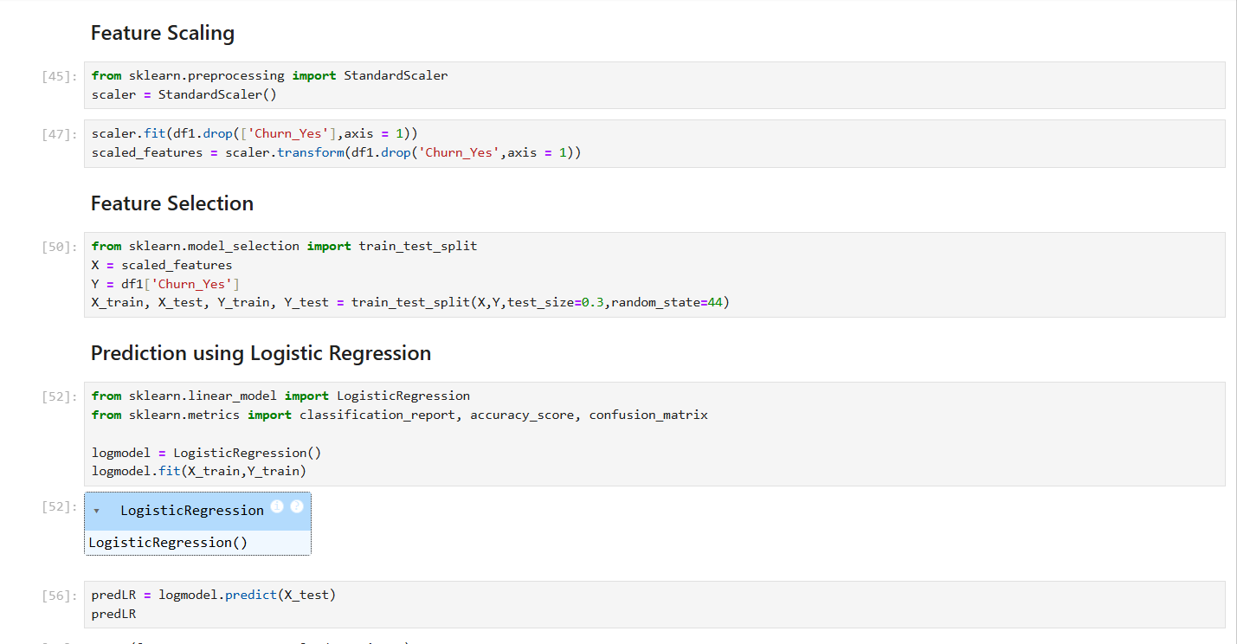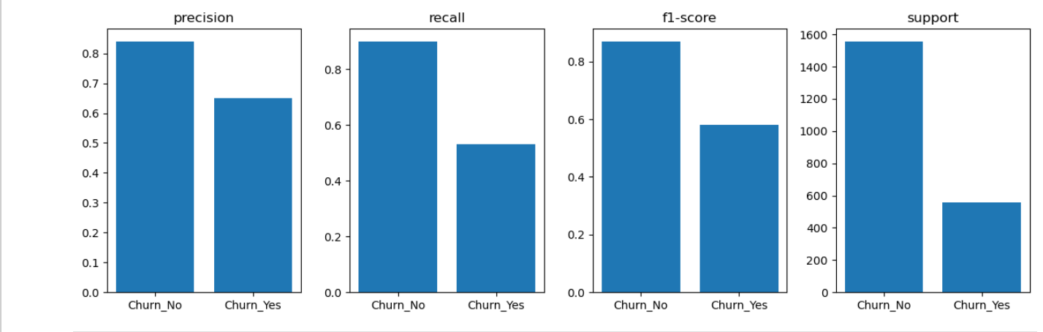
- Model Building: Machine learning algorithms like logistic regression, support vector classifier, decision trees, and K-Nearest Neighbor were applied to the data to predict customer churn.
- Logistic Regression: 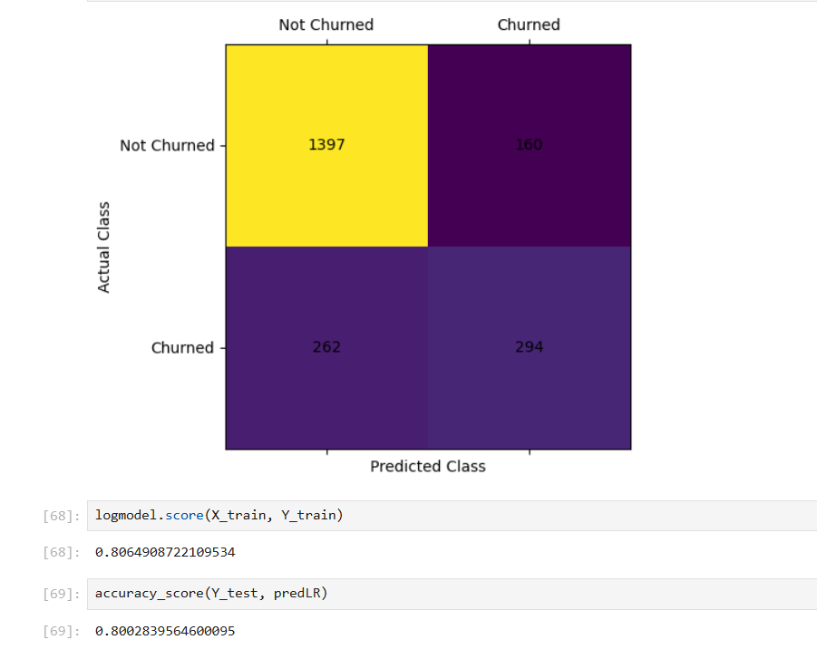
- Support Vector Classifier: 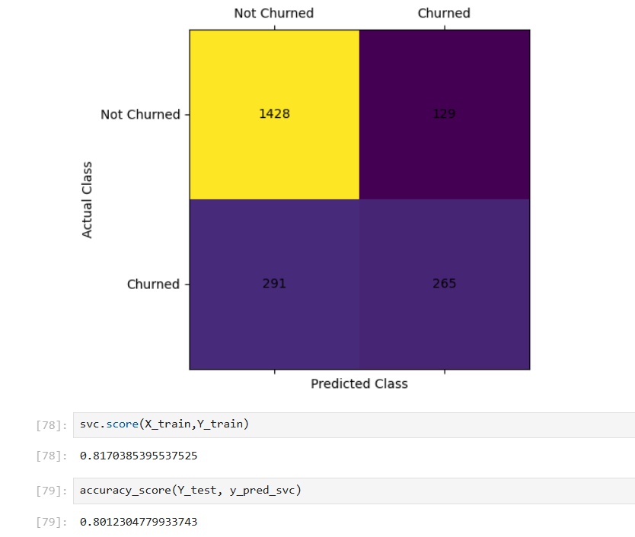
- Decision Tree Classifier: 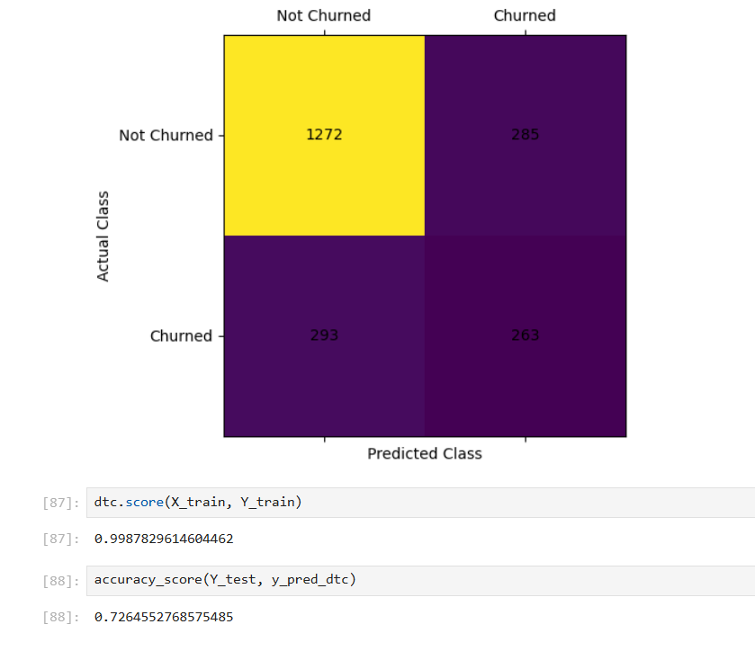
- K-Nearest Neighbor: 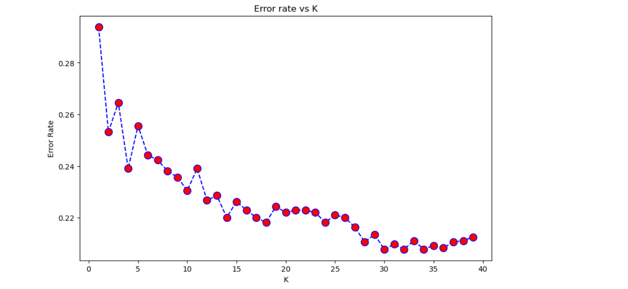
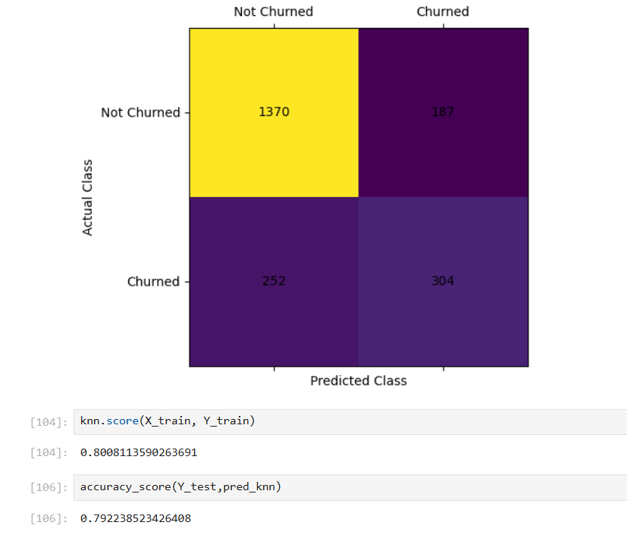

CHAPTER 4
Practical Implementation and Research

4.1 Work Description within the Organization
In this project, a thorough analysis of the customer churn dataset was performed, starting with data exploration and cleaning. The dataset was split into training and testing sets to evaluate model performance effectively. Machine learning models were built and tested, with logistic regression being the baseline model, followed by more complex models such as decision trees and knn.
4.2 Description of Study/Research Under the Supervision:
The research focused on building predictive models for customer churn prediction. Under the guidance of senior analysts, multiple algorithms were tested, and their performance was compared using accuracy, precision, recall, and F1 scores. Feature selection and hyperparameter tuning were also conducted to optimize the models' performance.
4.3 Challenges Faced
Feature Engineering: Determining which features would provide the most value to the predictive models was another challenge. While some features like tenure and monthly charges were intuitive, others required more experimentation. There was also a need to transform certain variables, such as payment method or contract type, into meaningful numerical representations.
Class Imbalance: In the context of customer churn, there is often an imbalance between the number of customers who churn and those who do not. This imbalance in the dataset made it difficult to train models effectively without introducing bias. Special techniques, such as oversampling the minority class or using balanced accuracy metrics, were required to address this issue.
Choosing the Right Model: Selecting the best machine learning model for churn prediction was a challenge. Although multiple models such as logistic regression, support vector classifier, decision tree classifier, and knn were tested, each came with its trade-offs. Logistic regression provided an easy-to-interpret model but lacked the complexity needed for non-linear relationships. Decision trees could overfit the data.
Interpreting Model Results: While certain models like logistic regression provided insights into the importance of each feature, more complex models such as support vector classifier or decision trees were harder to interpret. Understanding why the model made certain predictions and how the features interacted required additional techniques like feature importance scoring and partial dependence plots.
External Factors Not Captured in the Data: Customer churn can be influenced by external factors that were not present in the dataset, such as economic trends, competitor actions, or customer dissatisfaction beyond what was recorded. This limitation made it challenging to create a fully comprehensive model, as not all influencing factors were measurable

CHAPTER 5
Learning, Recommendations, and Conclusions

5.1 Behavioral Learning from Organization
This project provided insights into how businesses can utilize data to make informed decisions about customer retention strategies. The analysis highlighted the importance of factors such as contract duration, monthly charges, and customer service in determining the likelihood of churn.
5.2 Suggestions and Recommendations
- Personalized Offers: Telecom companies should offer personalized incentives to customers at risk of churning, based on their service usage patterns.
- Improved Customer Support: Investing in better customer support channels to address customer issues and complaints promptly could significantly reduce churn.
- Long-term Contracts: Encouraging customers to switch to longer-term contracts can help improve retention rates.
5.3 Limitations
- Data Limitations: The dataset may not capture external factors influencing churn, such as competitor pricing or economic conditions.
- Model Assumptions: The models assume that past customer behavior will remain consistent, which may not always be true.
5.4 Conclusion
Customer churn analysis is a crucial aspect of business strategy for telecom companies. Predictive models built using machine learning algorithms can help identify customers at risk of churning, enabling companies to implement proactive retention strategies. With further refinement, these models can become essential tools for decision-making in customer relationship management.

BIBLIOGRAPHY
Here are some key references and resources used throughout the customer churn analysis research:
- Books and Research Papers:
- Han, J., Pei, J., & Kamber, M. (2011). Data Mining: Concepts and Techniques. Morgan Kaufmann.
This book provided foundational concepts in data mining, machine learning techniques, and feature selection methods, which were applied in the customer churn analysis.
- Hastie, T., Tibshirani, R., & Friedman, J. (2009). The Elements of Statistical Learning. Springer Science & Business Media.
This book served as a reference for the machine learning algorithms used in the analysis, such as logistic regression, decision trees, and knn.
- Online Tutorials and Documentation:
- Scikit-learn Documentation (2025). Machine Learning in Python - Logistic Regression, Decision Trees, and Random Forests.
Retrieved from: https://scikit-learn.org/stable/documentation.html
This official documentation helped with the implementation of machine learning models, particularly for model training and evaluation. Matplotlib and Seaborn Documentation (2025).
- Data Visualization in Python
Retrieved from: https://matplotlib.org/stable/ and https://seaborn.pydata.org/
These resources provided guidance for creating visualizations during exploratory data analysis (EDA).
- Datasets:
The customer churn dataset used for the analysis was sourced from publicly available telecommunications datasets from Kaggle.

